**RAILWAY RESERVATION**

1.Update price of the ticket.

Hint:

This requires creation of two views.

One for calculating the price of one ticket for a given PNR. This involves computation of

distance traveled and fare per kilometer.

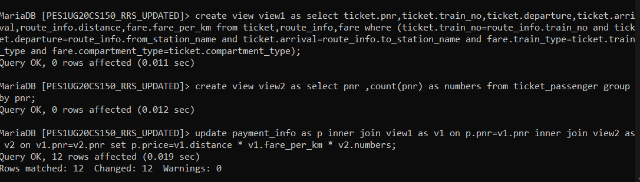

**NATURAL JOIN**

2. Retrieve the all stations along route of the Trains along with the distance between the

Stations

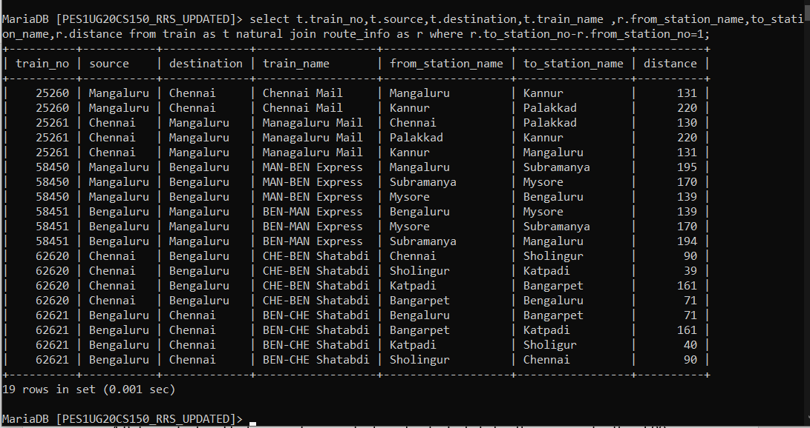

**INNER JOIN (equijoin)**

3.Retrieve the Train no of train which is leaving Bengaluru and arriving at Chennai with

compartments availability greater than 10

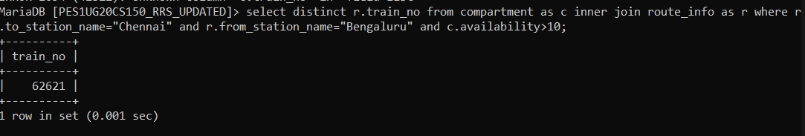

4.Retrieve first and last name of users who have booked a ticket with price greater than 500

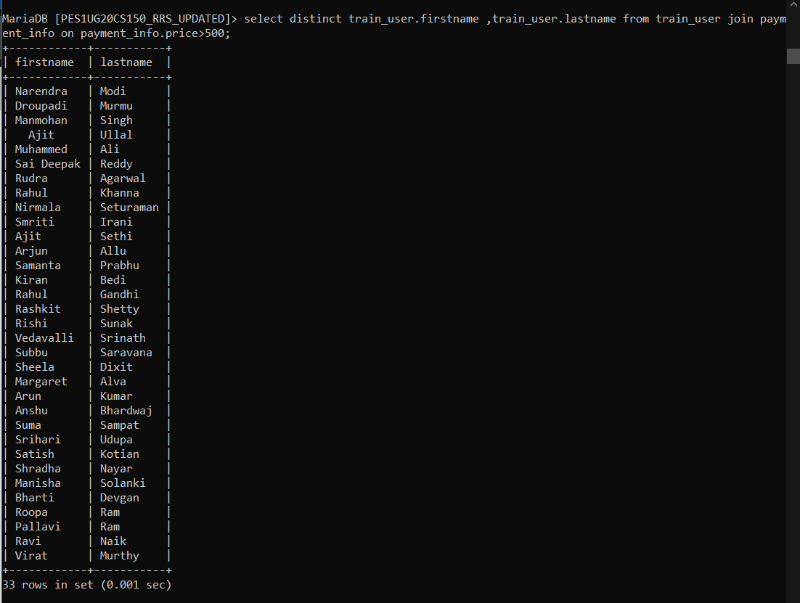

**LEFT OUTER JOIN**

5. Retrieve the first name, last name, DOB and ticket PNR if they’ve bought it for all users.

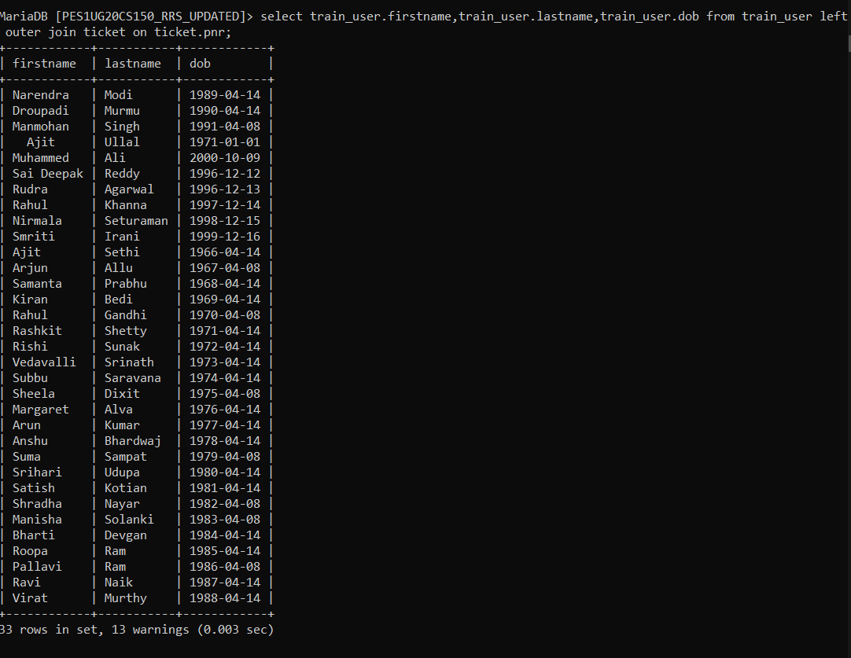

6. Retrieve the first name, last name,of the Users who have not bought a ticket

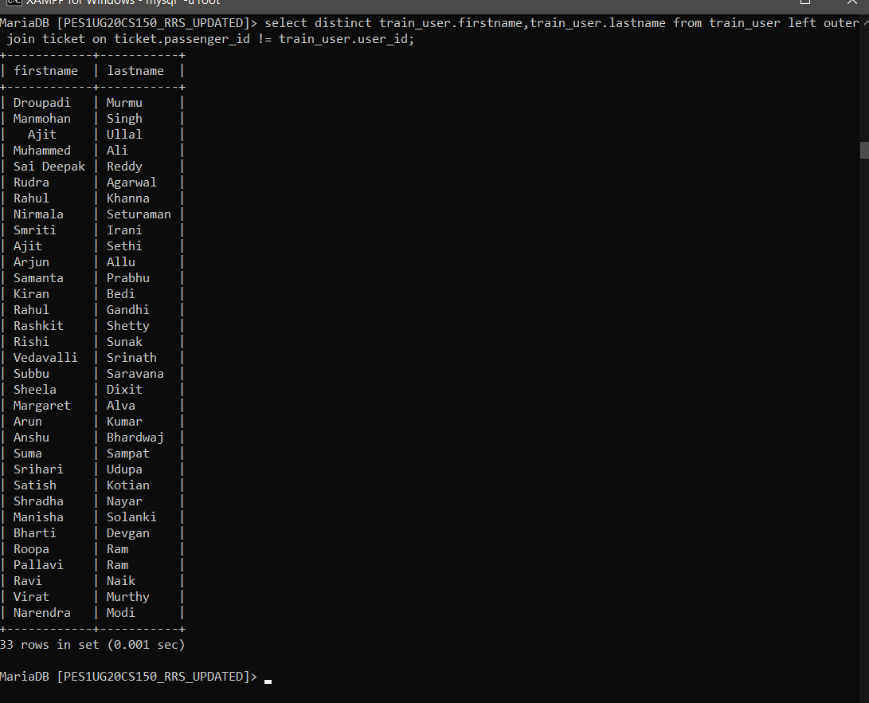

**RIGHT OUTER JOIN**

7. Retrieve the ticket PNR, Train number, travel date and along with all users first name and

last name.

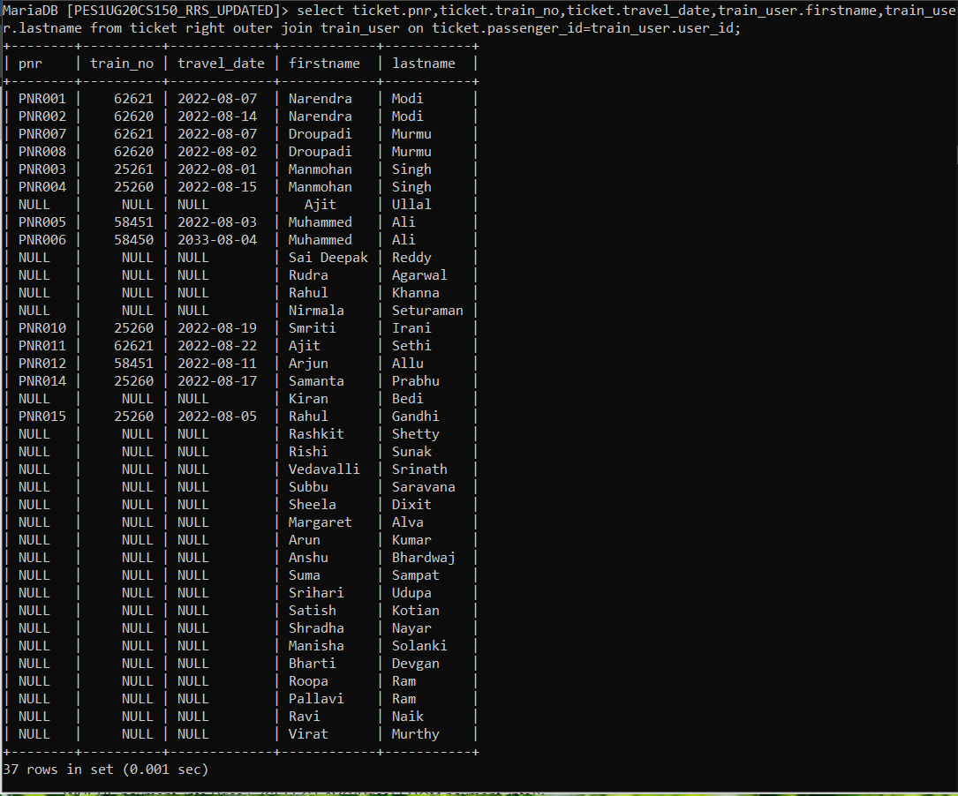

8. Retrieve the user id if they’ve traveled in a train along with train id and name of all trains.

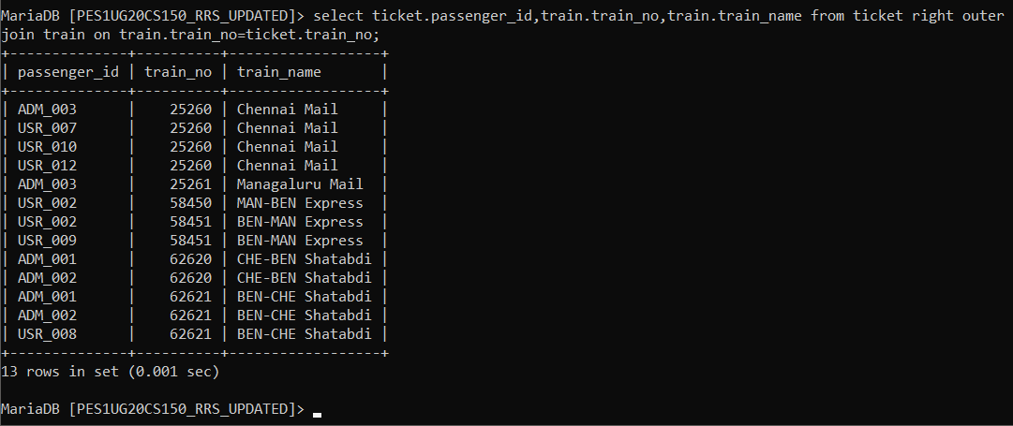

**NESTED QUERIES**

9. Retrieve the train no and name of trains whose destination is not Mangaluru and distance

is not less than 100km and departure time is not 8:30:00 PM.

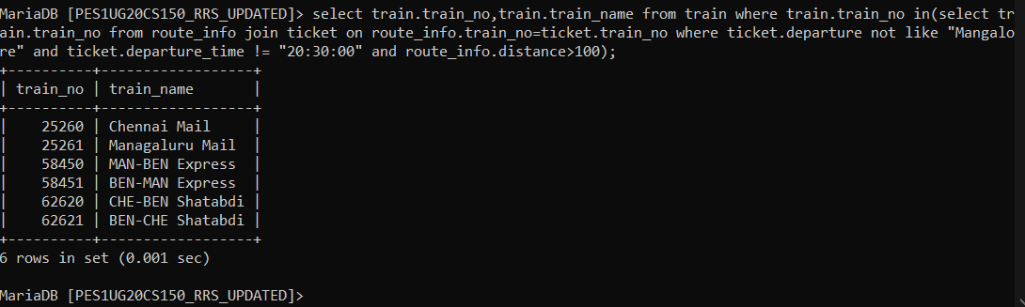

10. Retrieve the User ID who has spent more ticket price than the average ticket price.

